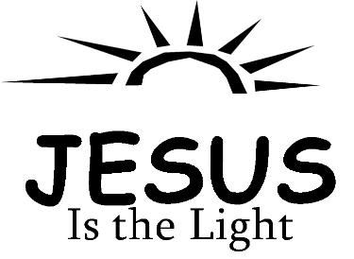
Copyright © Sermons4Kids, Inc.
May be reproduced for Ministry Use
Children’s Worship Bulletin

The Light of the World

John 1:1-18

Church Name
Address
City

Each number represents a letter of the alphabet. Substitute
the correct letter for the numbers to reveal the coded words.

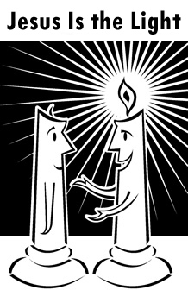

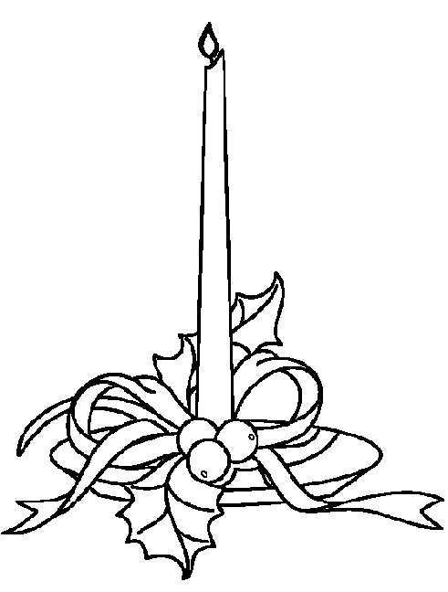

He himself was not the light: he came
only as a witness to the light.
John 1:8 (NIV)

